**Assignment 5**

**CS5800**

**Jonah Kubath**

**Summary**: The purpose of this assignment was to write a generic NFA-lambda converter to DFA. This program will take in an input file. The format of the input file is

1. Number of nodes
2. Final state nodes
3. Transition table for each node
   1. Can be empty or have multiple nodes for each transition
4. Input transitions
5. Can finish with a test line, but this is not used

**Run Results**: We were asked to run our NFA-lambda converter to print the needed file to run in our A4 DFA simulator. Once we had the input file, we were to then run two strings of length 7 characters or more on our A4 DFA simulator for testing. Those pictures are included.

All my A5 results are included in the folder:

/JonahKubath_CS5800_A5/a5_run_pictures

All my tests on the A4 simulator are included in the folder:

/JonahKubath_CS5800_A5/a5_run_pictures/a4_run

Here are some of the results

A5_ex_5.6.1_run.PNG

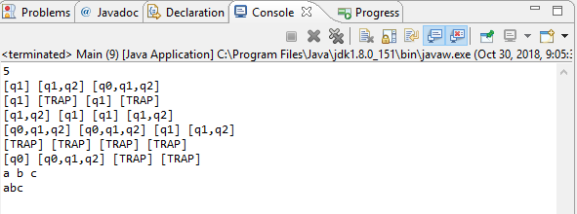

a4_ex_5.6.1_accept.PNG

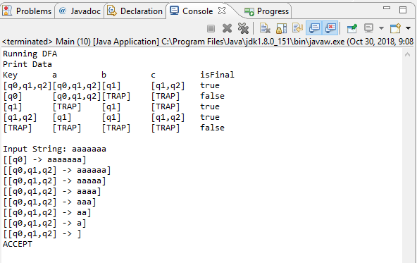a4_ex_5.6.1_reject.PNG

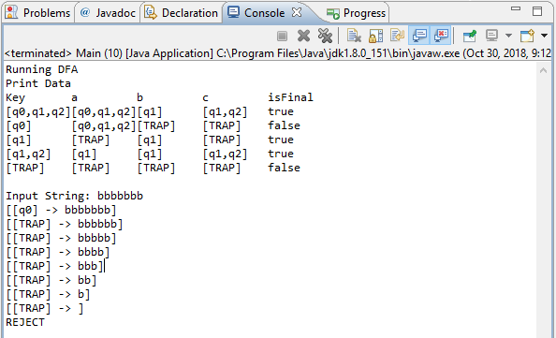

**Results**: The results are not very surprising. The NFA-lambda is converted into a DFA. Depending on how complicated the original NFA-lambda is can make the DFA complicated. Nodes will be combined and the result DFA can become quite large.

**Compilation**: I used the Eclipse IDE to export a runnable JAR file. The Java JVM will handle running the JAR on each system. This allows the executable to be run on various systems.

**Execution**: Open terminal or a command prompt and navigate to my project directory

JonahKubath_CS5800_A5

You should be able to see the jar file: JonahKubath_CS5800_A5.jar

Run: java -jar JonahKubath_CS5800_A5.jar <filename>

The filename for input is the first argument. This can be left blank and there are default files the program will look for. If the file is not found, an error message will be printed, and execution stopped. My program also assumes that the starting node will be “q0”. If this is not the case, an error will be printed, and execution will be stopped. This can be changed by changing the global variable “start”.

The project can also be run by opening the project in Eclipse. Arguments can be passed by setting the run time configuration for this project.